<https://www.youtube.com/watch?v=J4Wdy0Wc_xQ&list=PLblh5JKOoLUICTaGLRoHQDuF_7q2GfuJF&index=43>

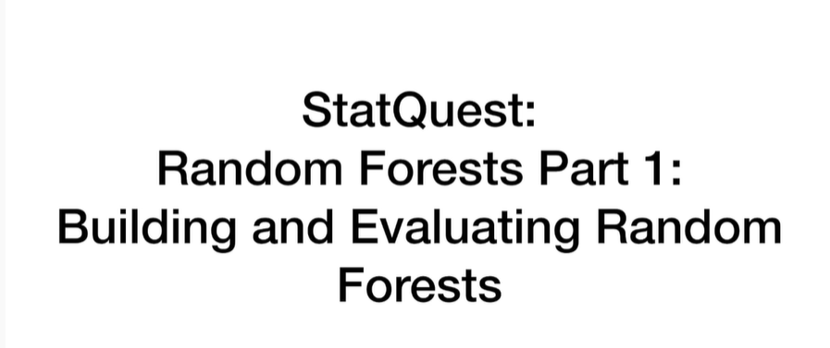

Today we're gonna be starting part one of a series on random forests and we're going to talk about building and evaluating random forests.

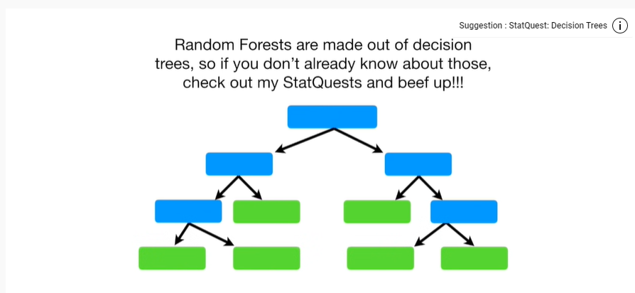

Note : random forests are built from decision trees.

So if you don't already know about those check out my stat quest and beef up.

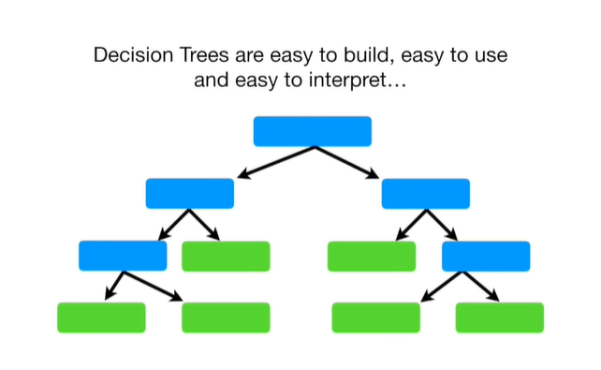

Decision trees are easy to build easy to use and easy to interpret

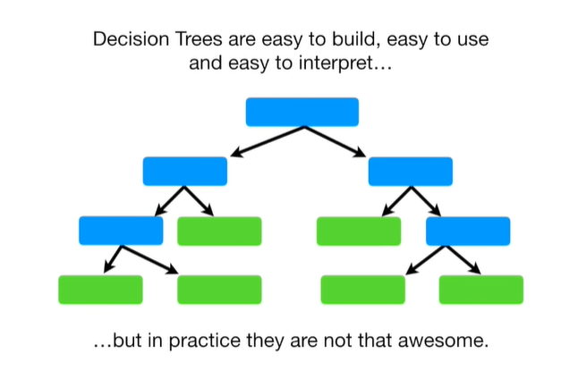

but in practice they are not that awesome.

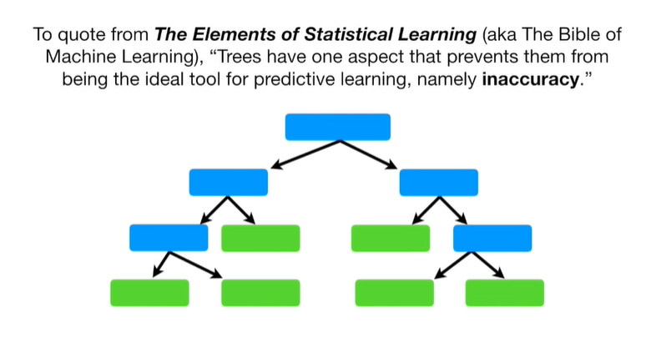

To quote from the elements of statistical learning (aka the Bible of machine learning), trees have one aspect that prevents them from being the ideal tool for predictive learning namely in accuracy.

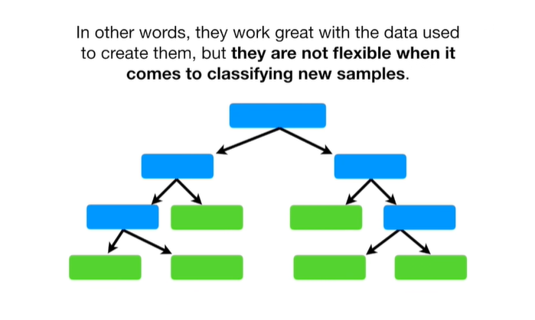

In other words, they work great with the data used to create them, but they are not flexible when it comes to classifying new samples.

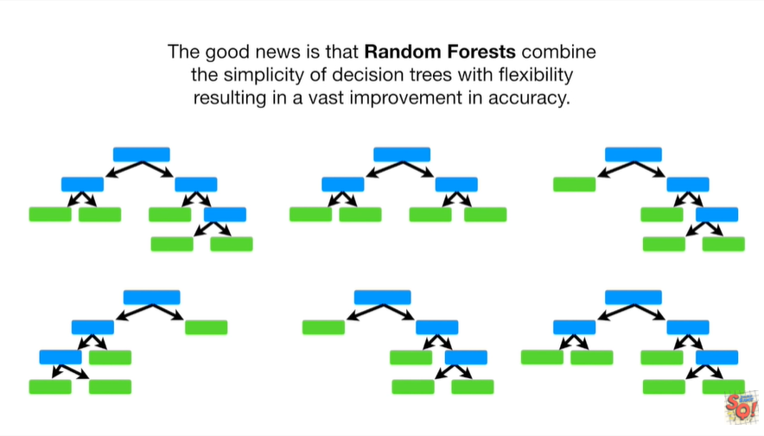

The good news is that random forests combine the simplicity of decision trees with flexibility resulting in a vast improvement in accuracy.

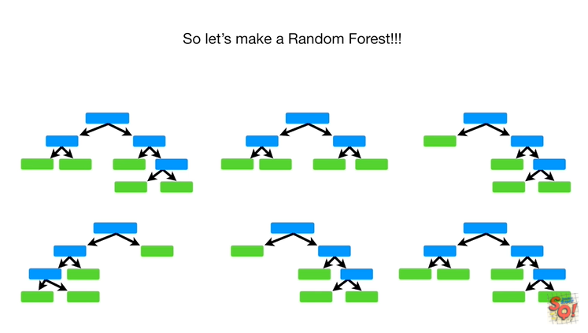

So let's make a random forest.

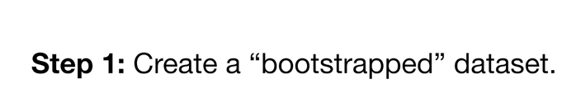

Step 1 : create a bootstrap data set.

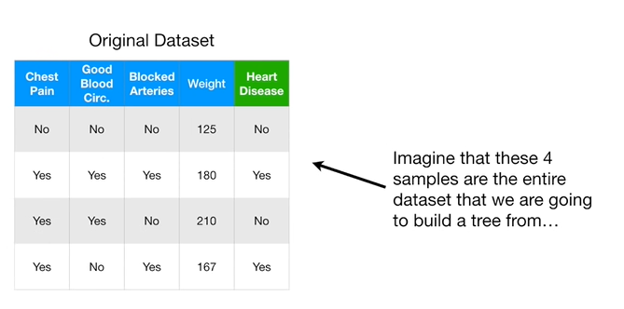

Iimagine that these 4 samples are the entire data set that we are going to build a tree from.

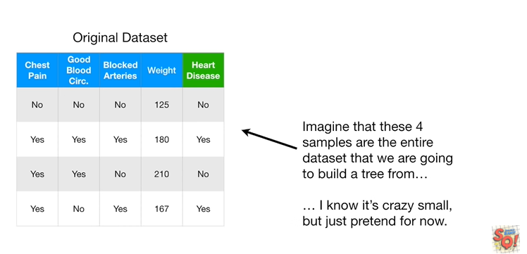

I know it's crazy small but just pretend for now.

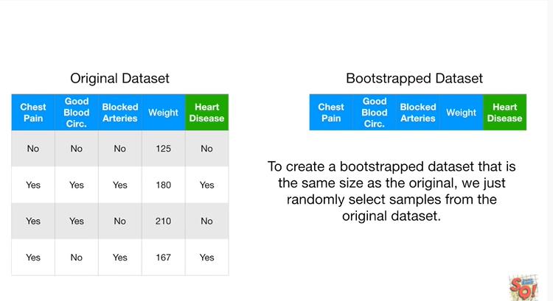

To create a bootstrap data set that is the same size as the original, we just randomly select samples from the original data set.

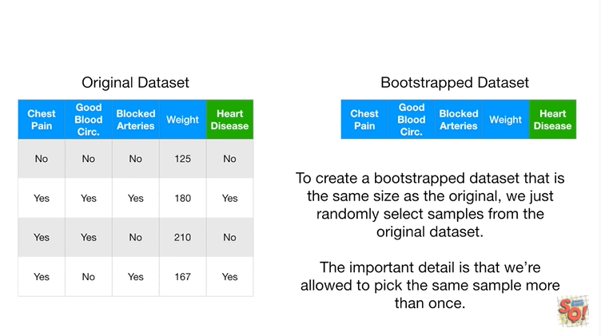

The important detail is that we're allowed to pick the same sample more than once.

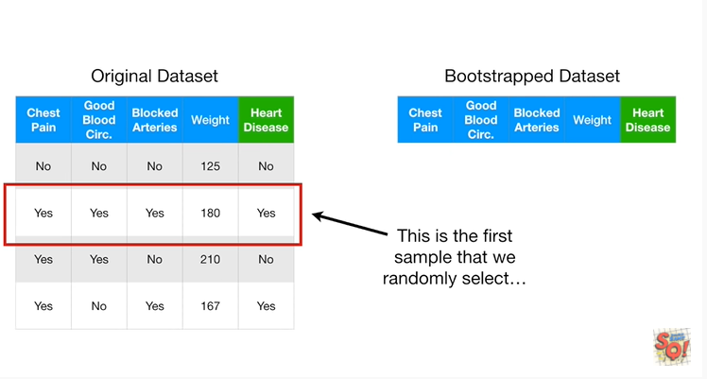

This is the first sample that we randomly select

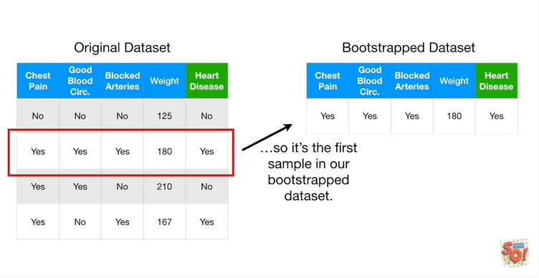

so it's the first sample in our bootstrap data set.

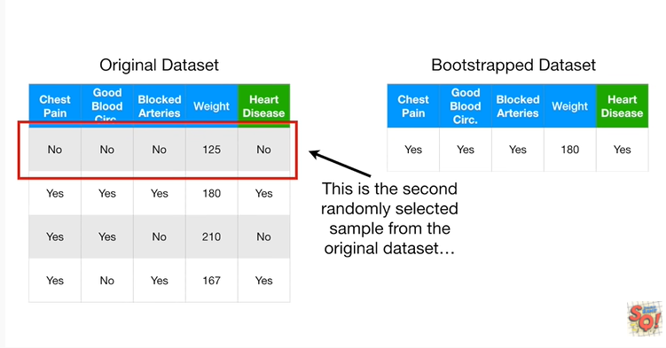

This is the second randomly selected sample from the original data set

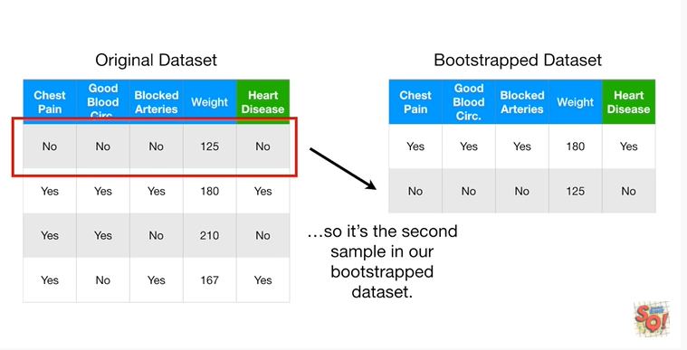

so it's the second sample in our bootstrap data set.

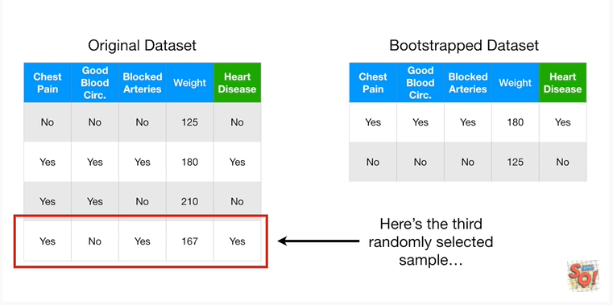

Here's the third randomly selected sample

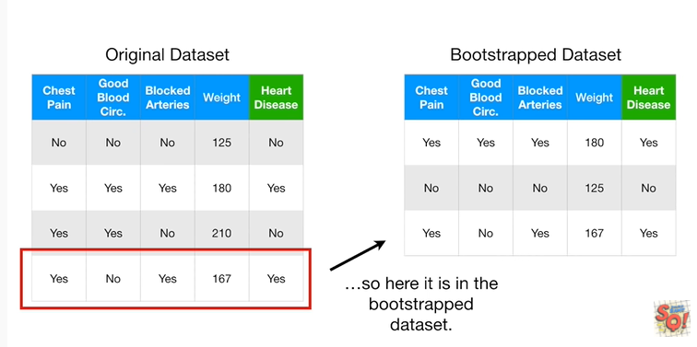

so here it is in the bootstrap data set.

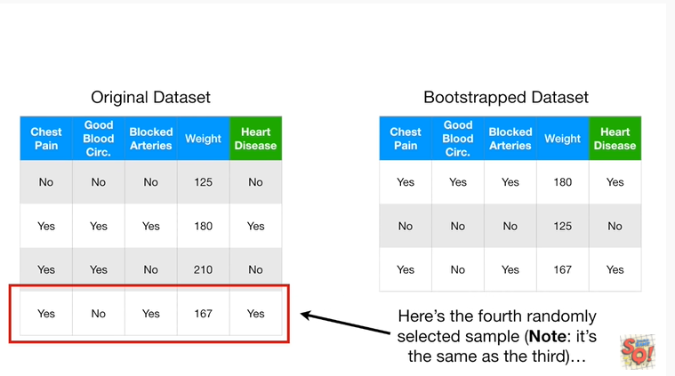

Lastly, here's the fourth randomly selected sample.

Note : it's the same as the third

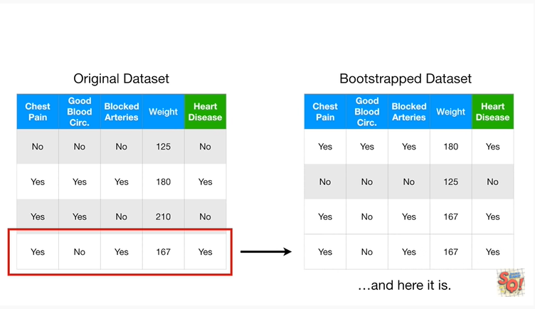

and here it is.

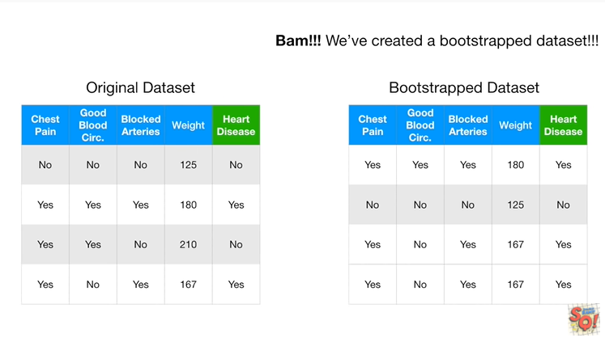

BAM !!!

We've created a bootstrap data set.

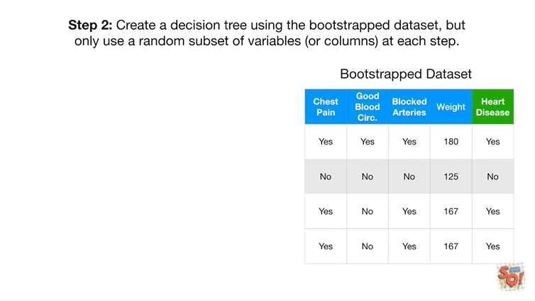

Step2 : for creating a random forest is to create a decision tree using the bootstrap dataset but only use a random subset of variables or columns at each step.

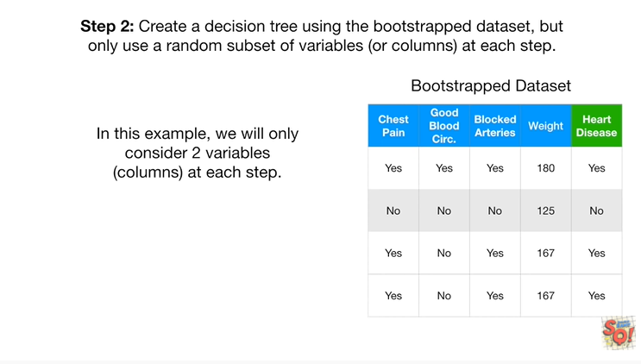

In this example we will only consider two variables or columns at each step.

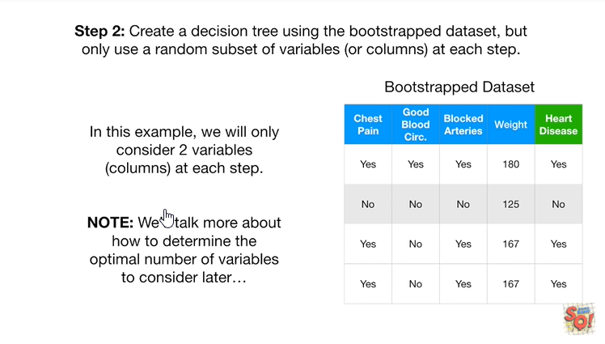

Note : we'll talk more about how to determine the optimal number of variables to consider later.

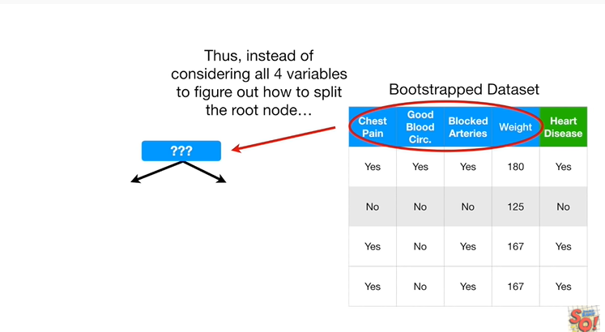

Thus instead of considering all four variables to figure out how to split the root node

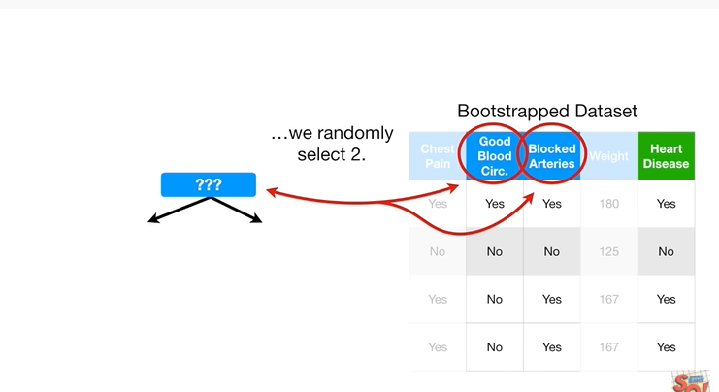

we randomly select two.

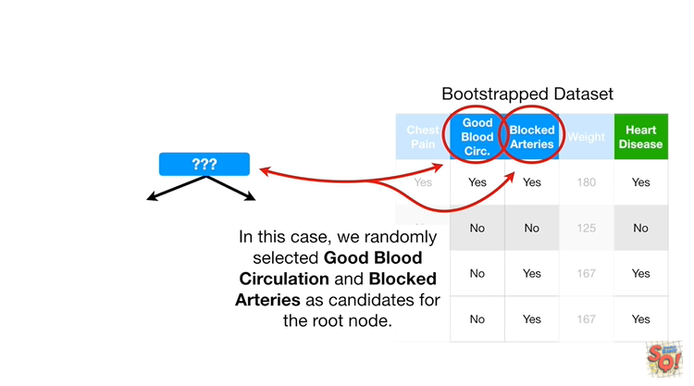

In this case we randomly selected good blood circulation and blocked arteries as candidates for the root node.

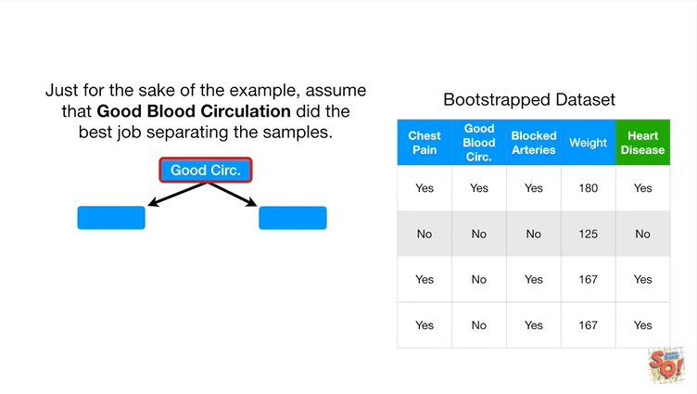

Just for the sake of the example assume that good blood circulation did the best job separating the samples.

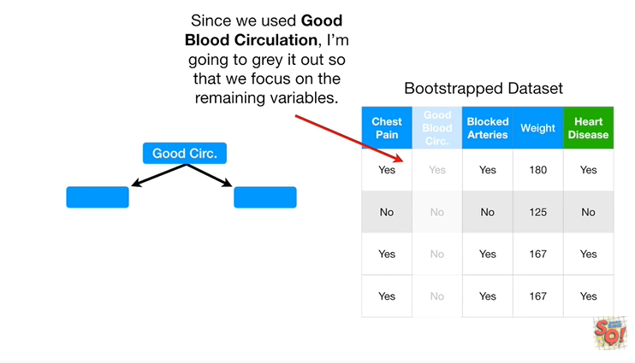

Since we used a good blood circulation, I'm going to gray it out so that we focus on the remaining variables.

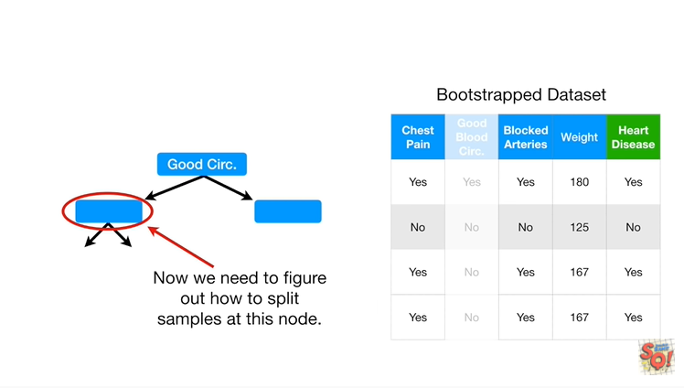

Now we need to figure out how to split samples at this node.

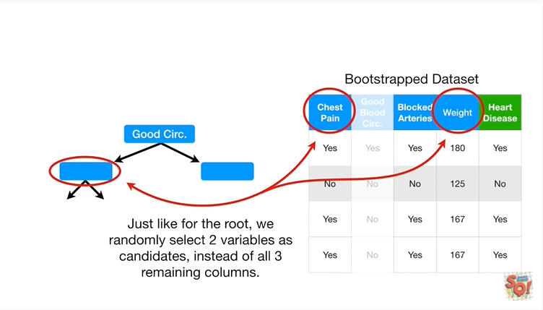

Just like for the route, we randomly select two variables as candidates, instead of all three remaining columns.

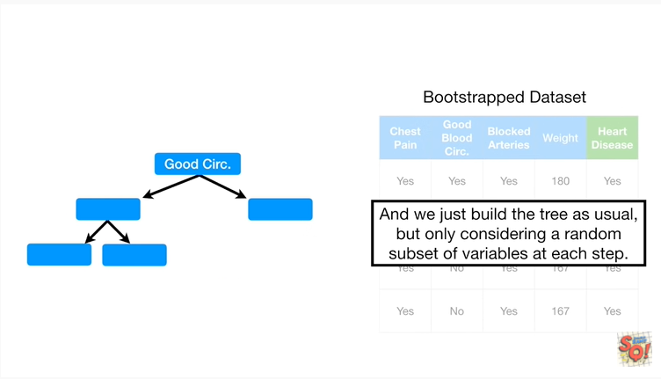

And we just build the tree as usual, but only considering a random subset of variables at each step.

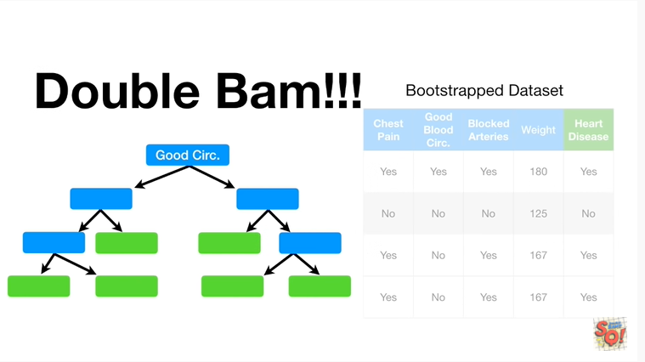

Double bam !!!

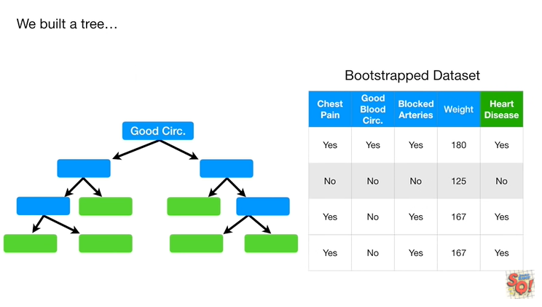

We built a tree :

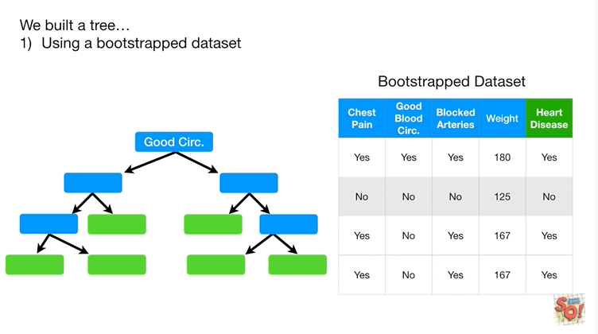

1. using a bootstrap data set

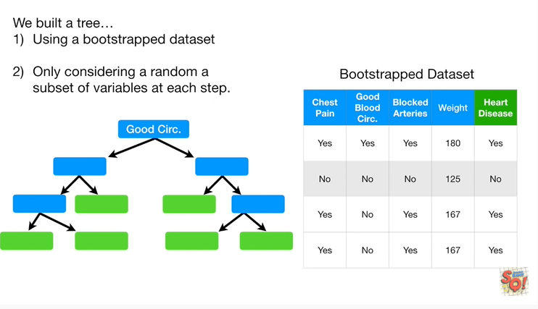

and 2. only considering a random subset of variables at each step.

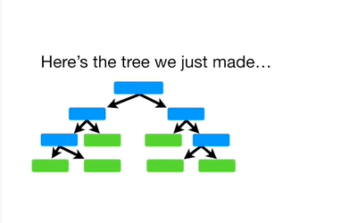

Here's the tree we just made.

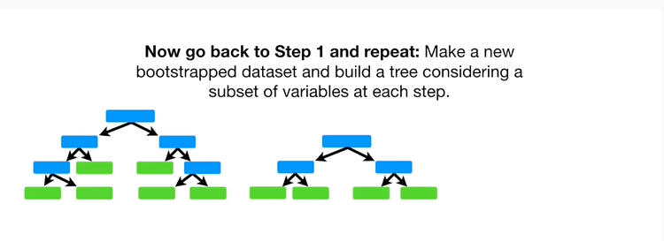

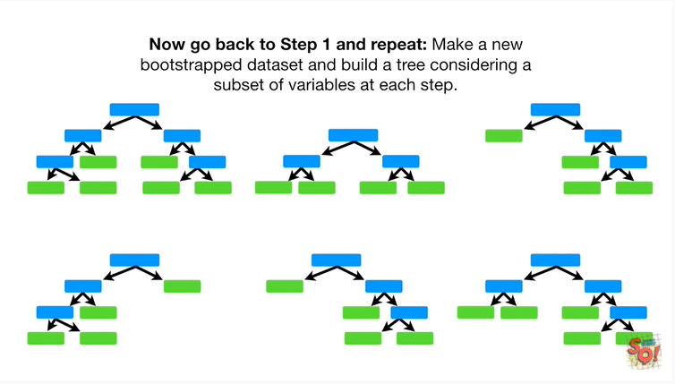

Now go back to step one and repeat : make a new bootstrap data set and build a tree considering a subset of variables at each step.

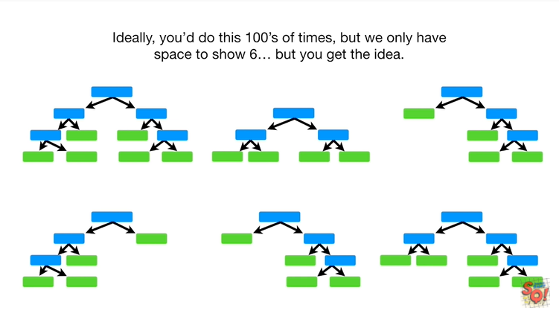

Ideally, you do this hundreds of times, but we only have space to show six …but you get the idea.

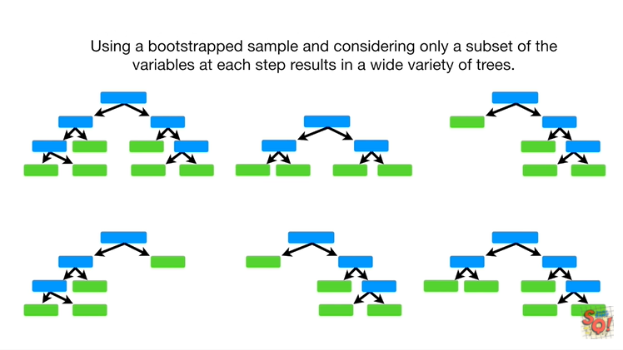

Using a bootstrap sample and considering only a subset of variables at each step results in a wide variety of trees.

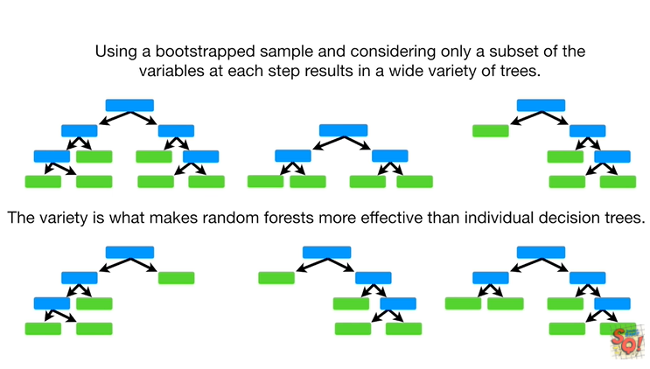

The variety is what makes random forests more effective than individual decision trees.

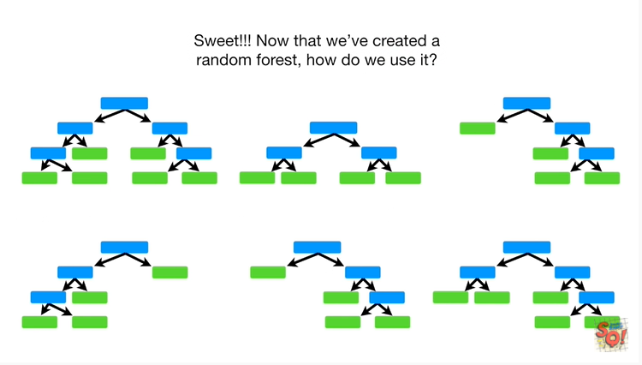

Sweet !!!

Now that we've created a random forest, how do we use it ?

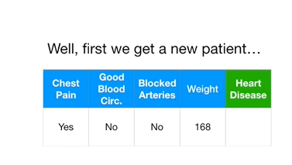

Well first we get a new patient

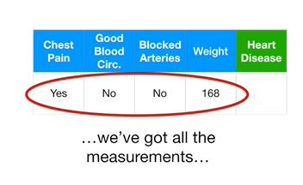

we've got all the measurements

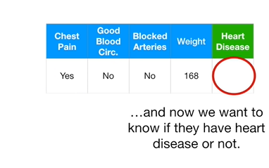

and now we want to know if they have heart disease or not.

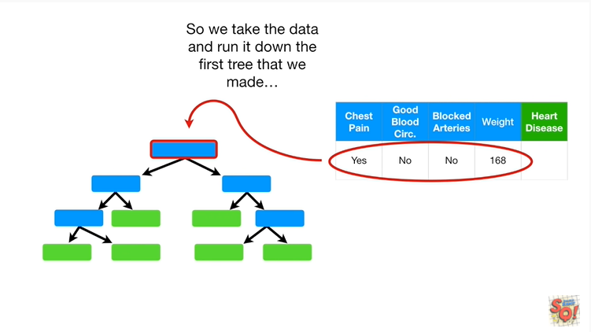

So we take the data and run it down the first tree that we made

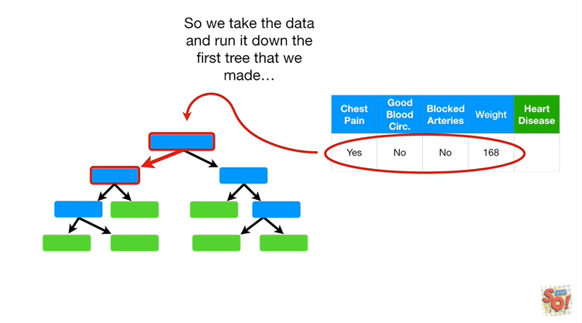

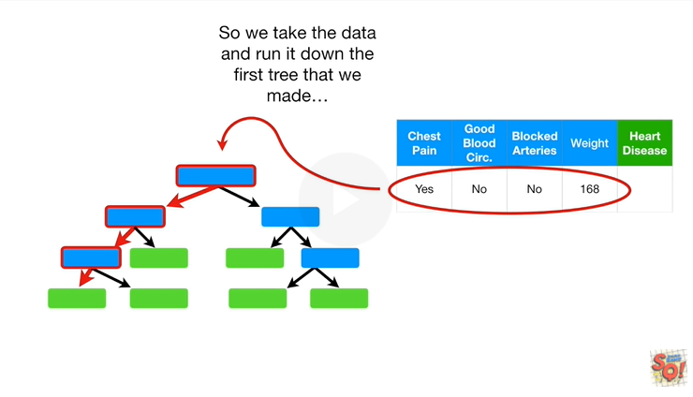

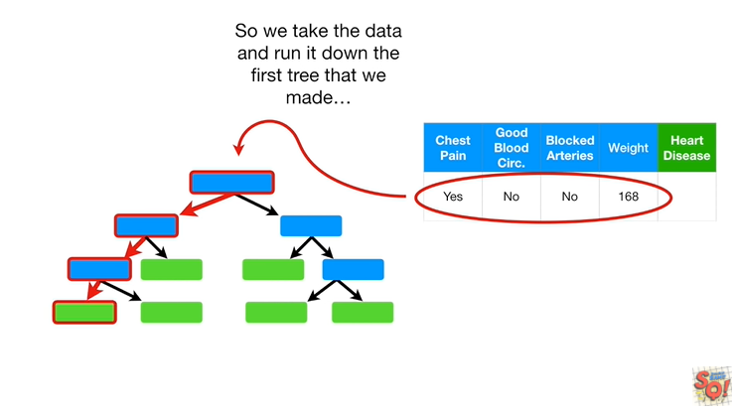

booboo dooba dooba dooba dooba dooba do.

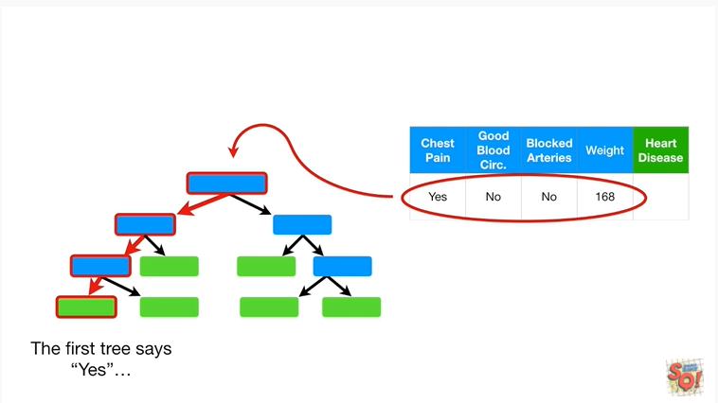

The first tree says yes, the patient has heart disease

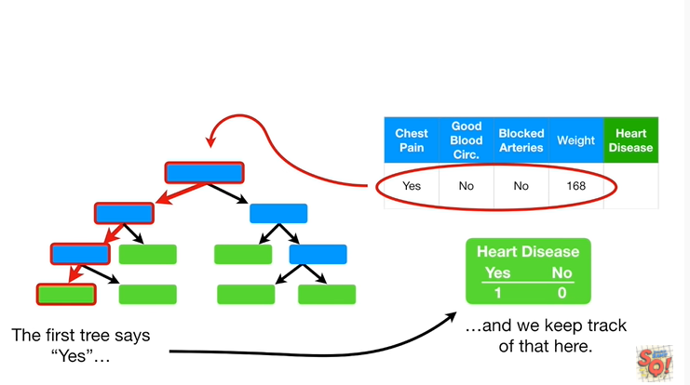

and we keep track of that here.

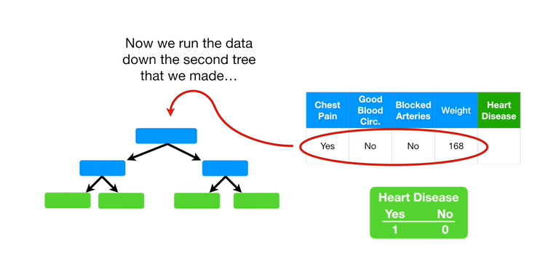

Now we run the data down the second tree that we made

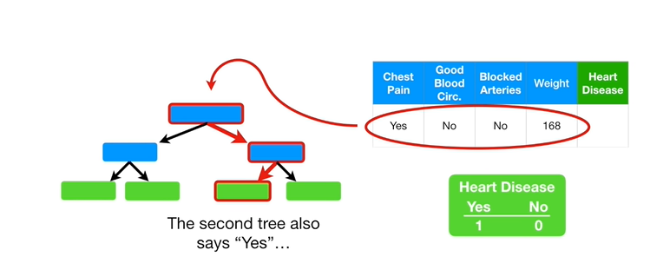

the second tree also says yes

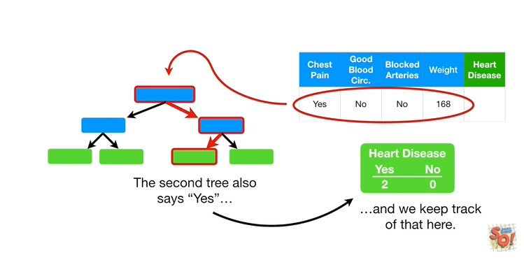

and we keep track of that here

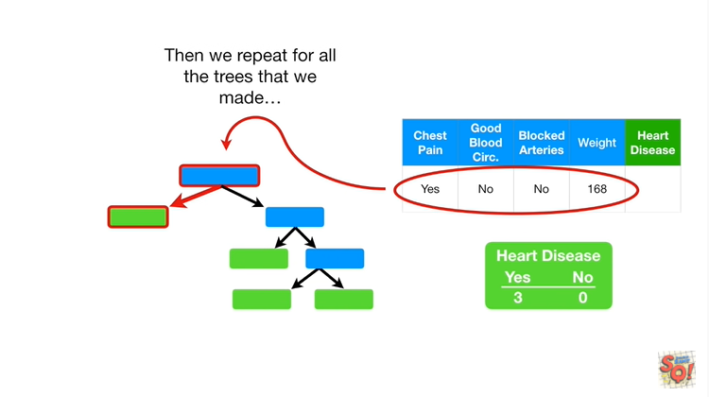

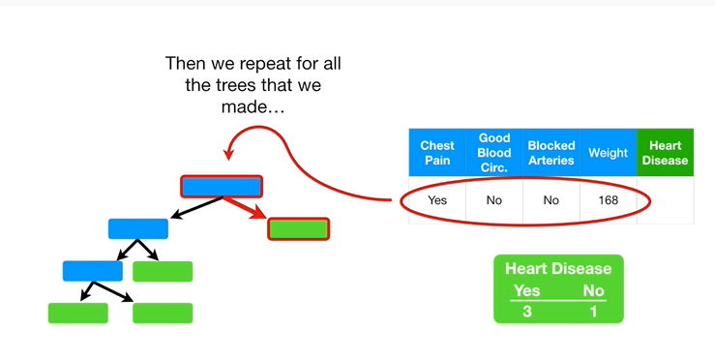

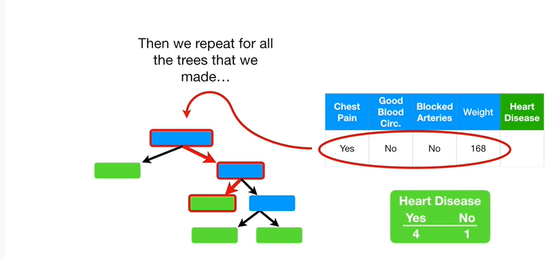

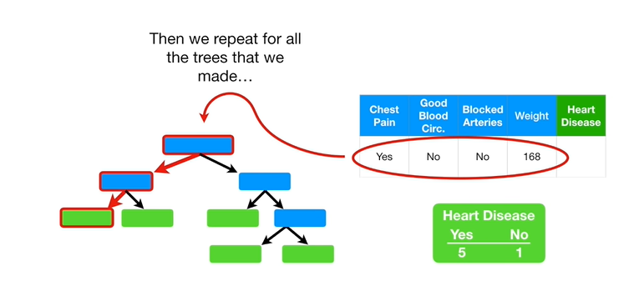

and then we repeat for all the trees we made.

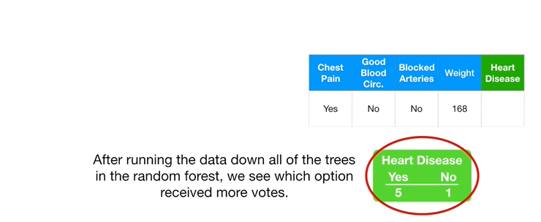

After running the data down all of the trees in the random forest we see which option received more votes.

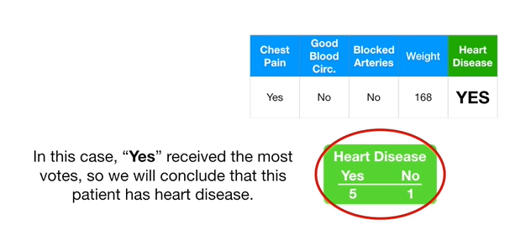

In this case, yes received the most votes, so we will conclude that this patient has heart disease.

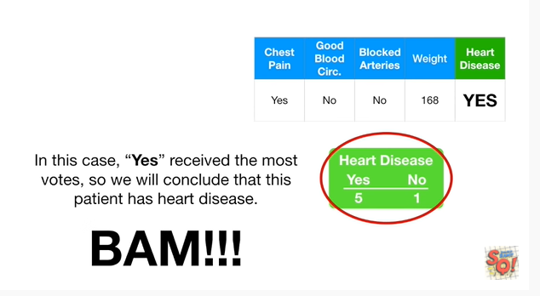

BAM !!!

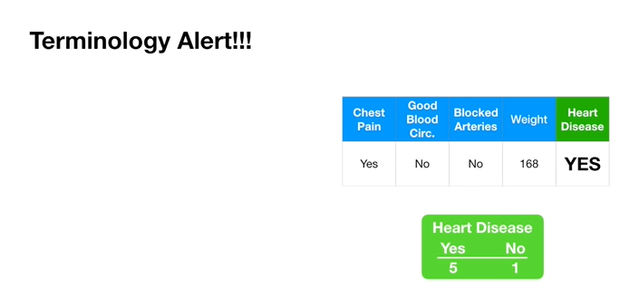

Oh No terminology alert !!!

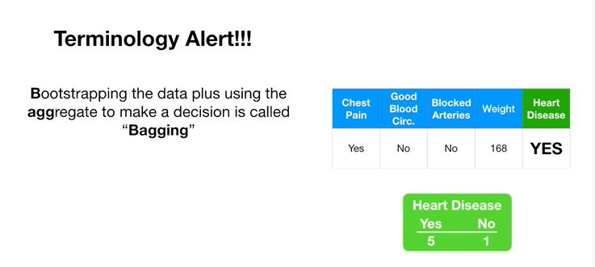

Bootstrapping the data plus using the aggregate to make a decision is called **bagging.**

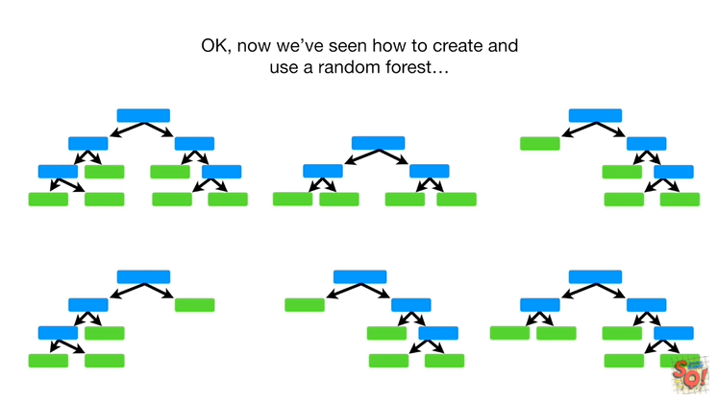

Okay, now we've seen how to create and use a random forest.

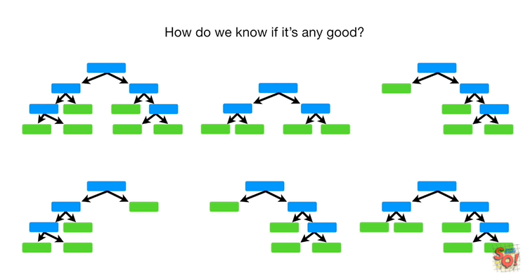

How do we know if it's any good ?

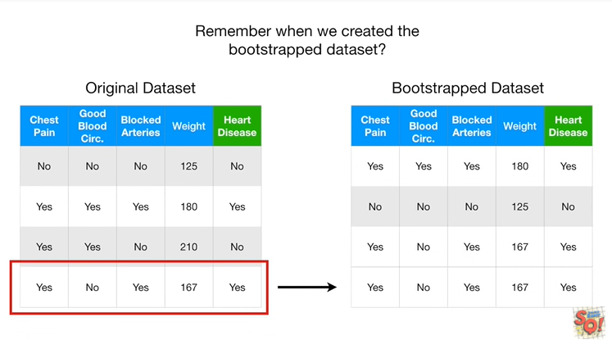

Remember when we created the bootstrapped data set ?

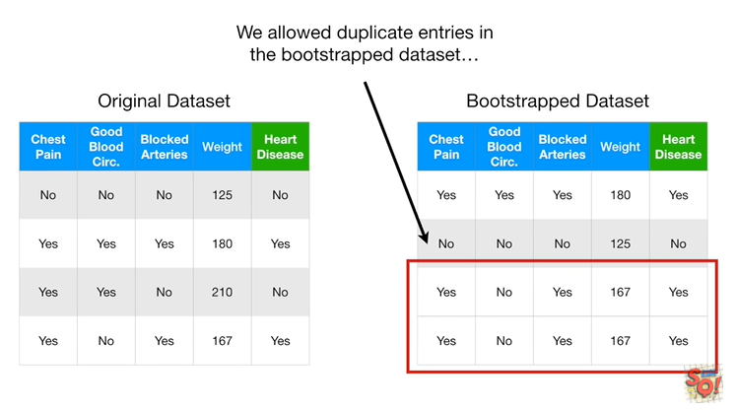

We allow duplicates in trees in the bootstrapped data set.

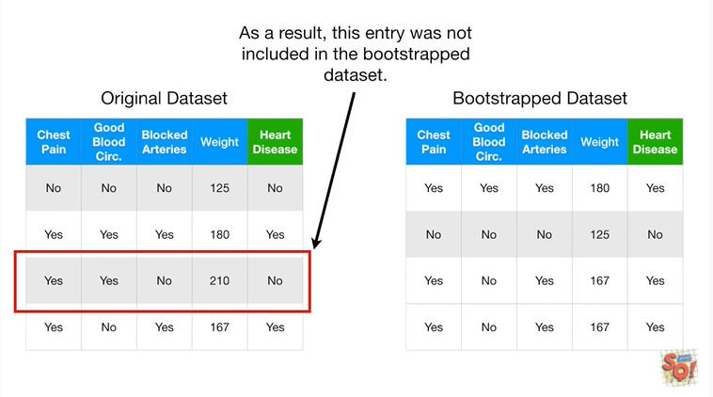

As a result this entry was not included in the bootstrap data set.

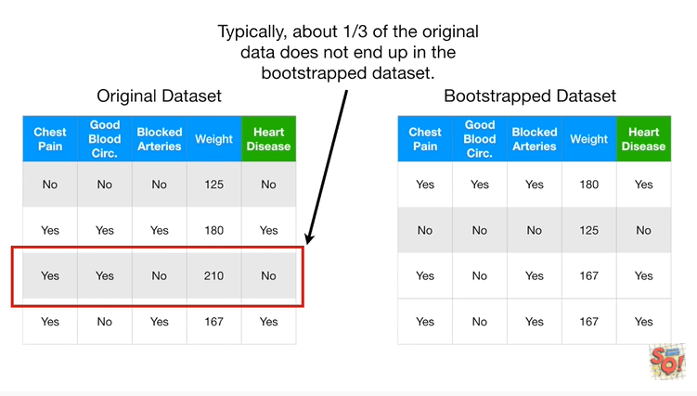

Typically, about one third of the original data does not end up in the bootstrap data set.

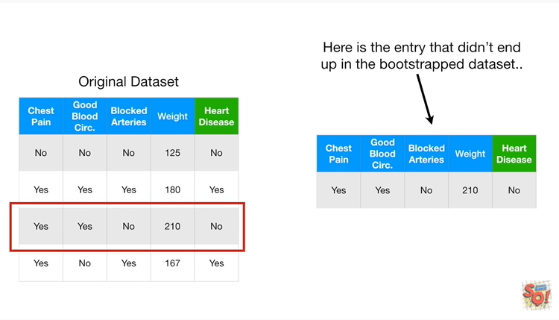

Here's the entry that didn't end up in the bootstrapped dataset.

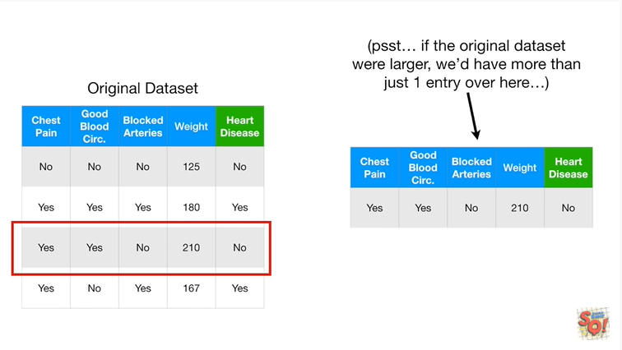

Psst : if the original dataset were larger we'd have more than just one entry over here.

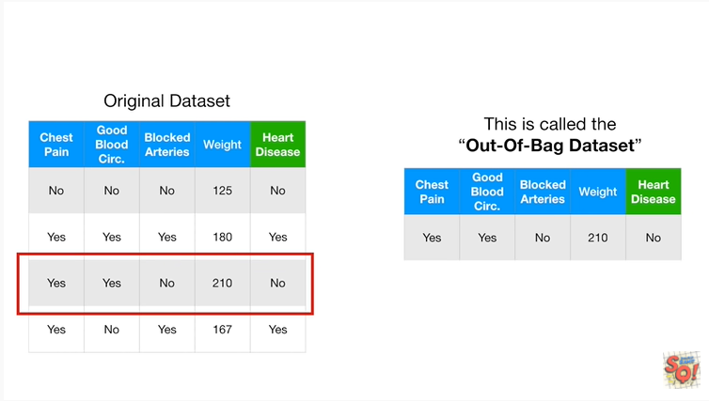

This is called the out-of-bag data set.

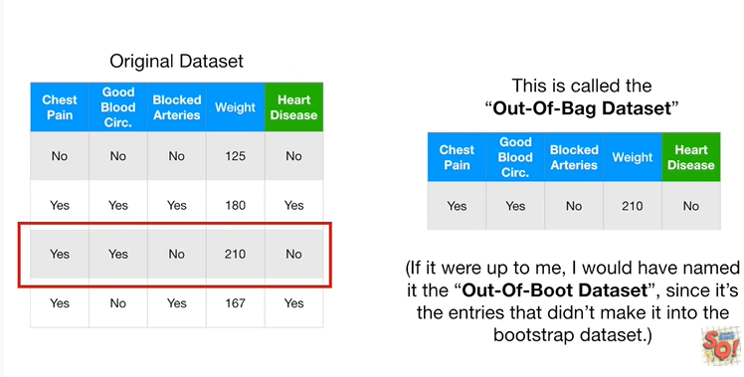

If it were up to me, I would have named it thee out of boot data set, since it's the entries that didn't make it into the bootstrap dataset.

Unfortunately it's not up to me.

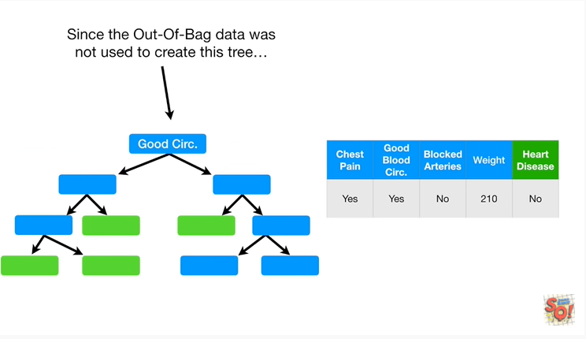

Since the out-of-bag data was not used to create this tree

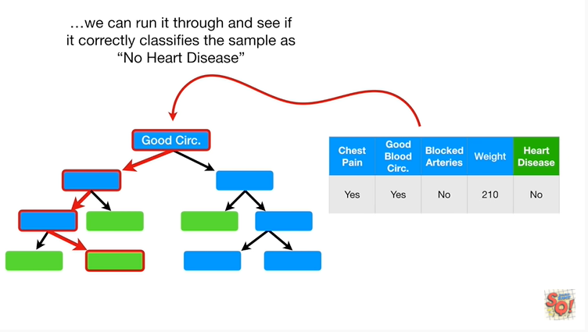

we can run it through and see if it correctly classifies the sample as no heart disease.

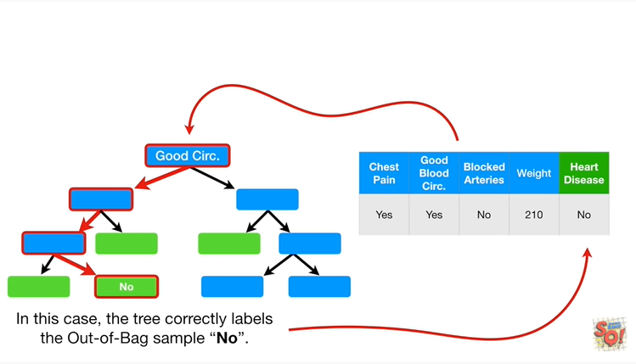

In this case the tree correctly labels the out of bag sample, no.

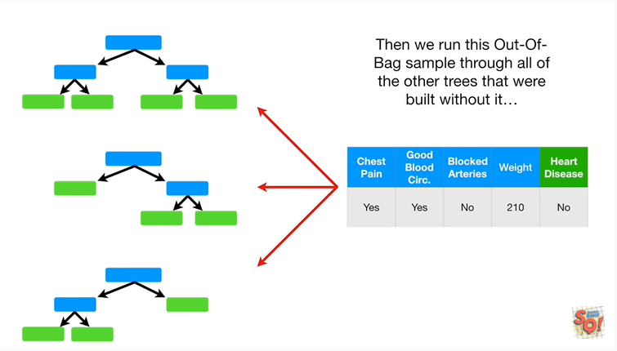

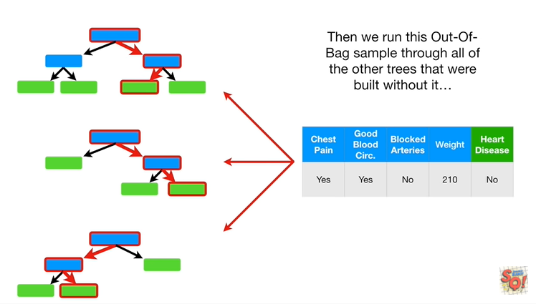

Then we run this out of bag sample through all of the other trees that were built without it.

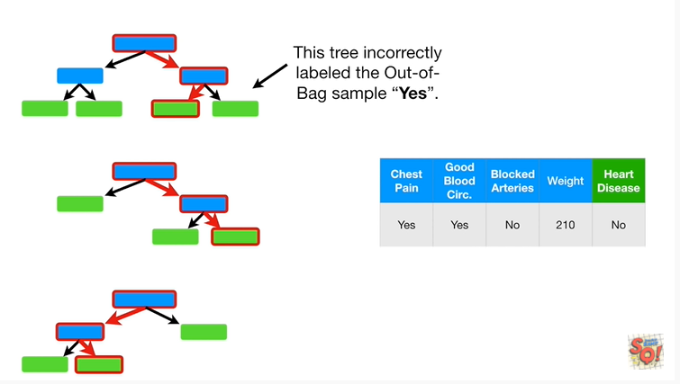

This tree incorrectly labeled the out of bag sample yes.

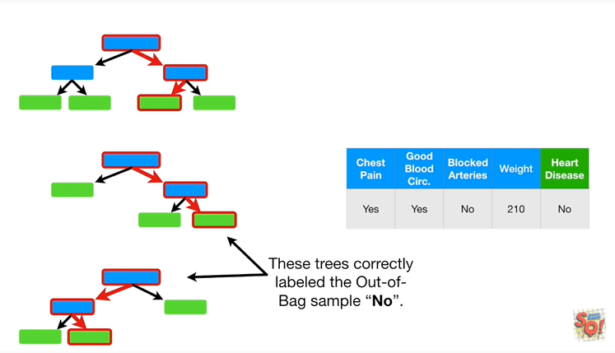

These trees correctly labeled the out of bag sample, No.

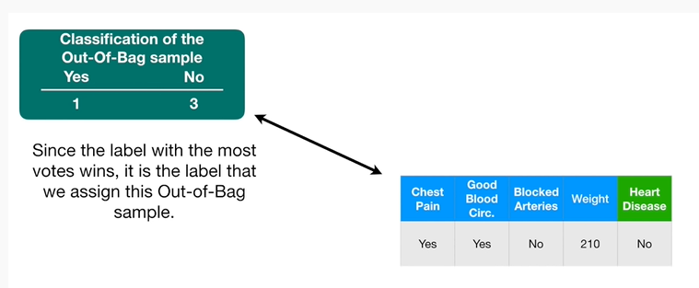

Since the label with the most votes wins, it is the label that we assign this out of bag sample.

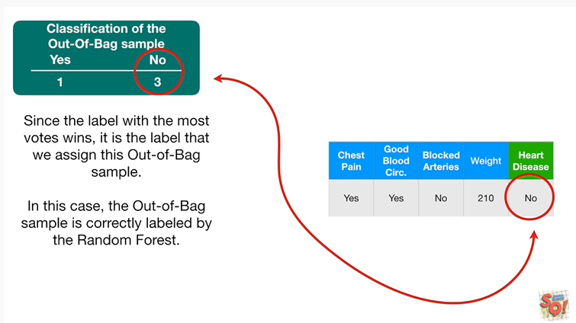

In this case, the out of bag sample is correctly labeled by the random forest.

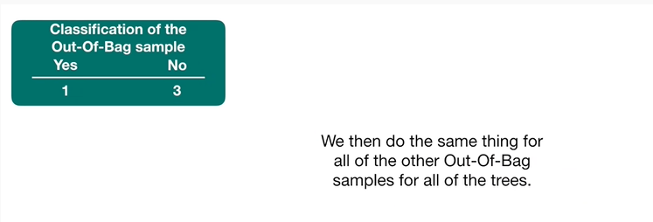

We then do the same thing for all of the other out of bag samples for all of the trees.

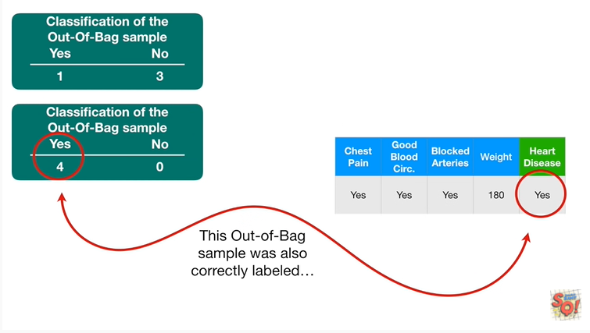

This out of bag sample was also correctly labeled.

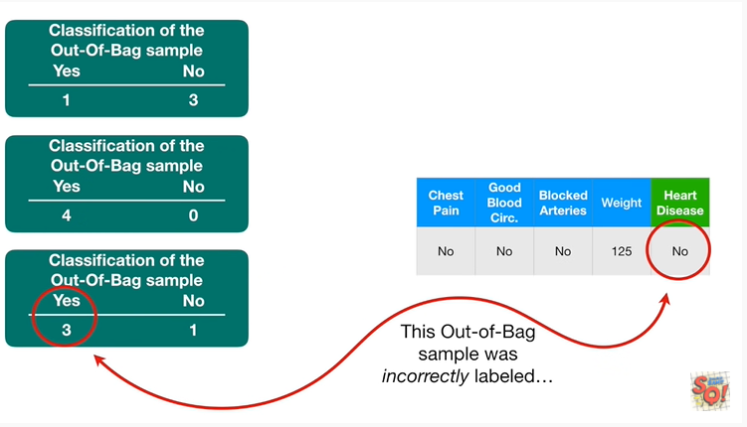

This out of bag sample was incorrectly labeled.

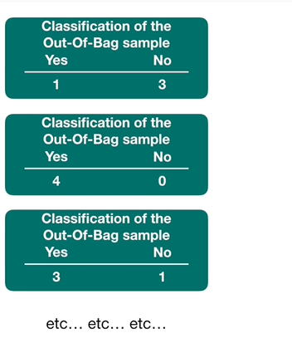

Etc etc etc …

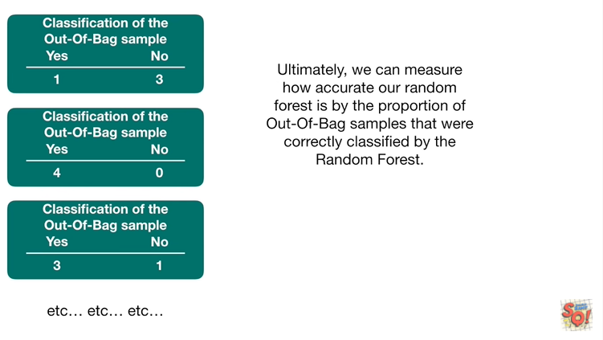

Ultimately, we can measure how accurate our random forest is by the proportion of out-of-bag samples that were correctly classified by the random forest.

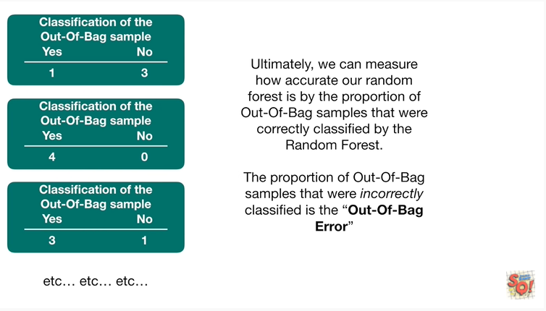

The proportion of out-of-bag samples that were incorrectly classified is the out of bag error.

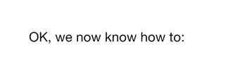

Okay, we now know how to :

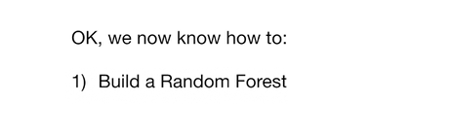

1. build a random forest

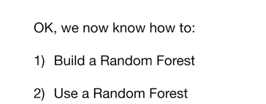

2. use a random forest

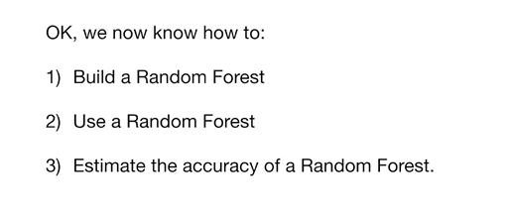

and 3. estimate the accuracy of a random forest.

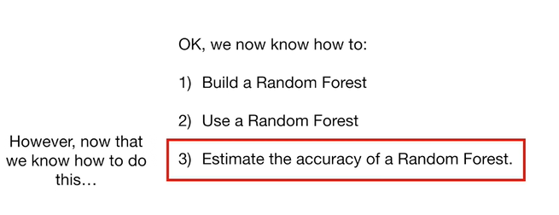

However, now that we know how to do this

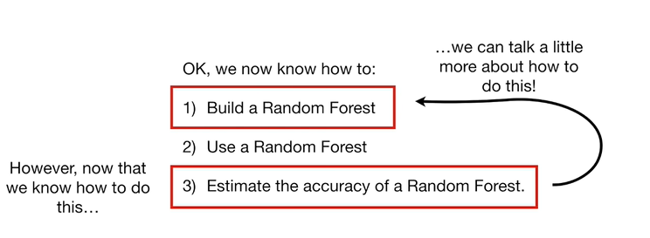

we can talk a little more about how to do this !

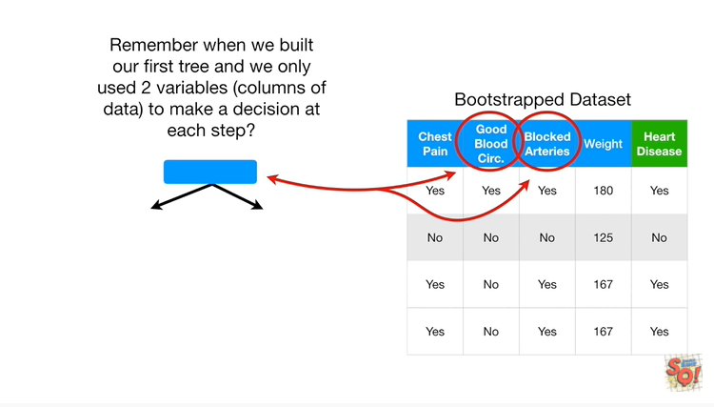

Remember when we built our first tree and we only use two variables (columns of data) to make a decision at each step ?

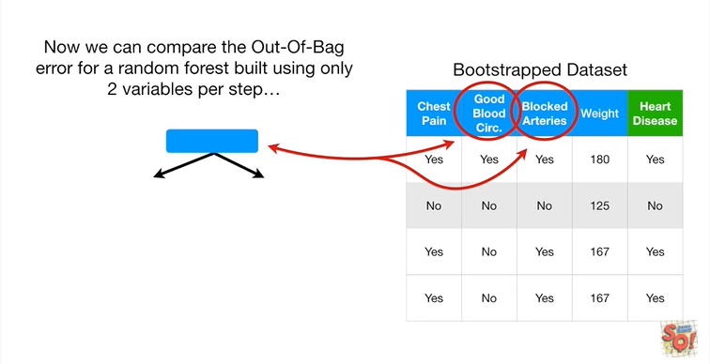

Now we can compare the out-of-bag error for a random forest built using only two variables per step

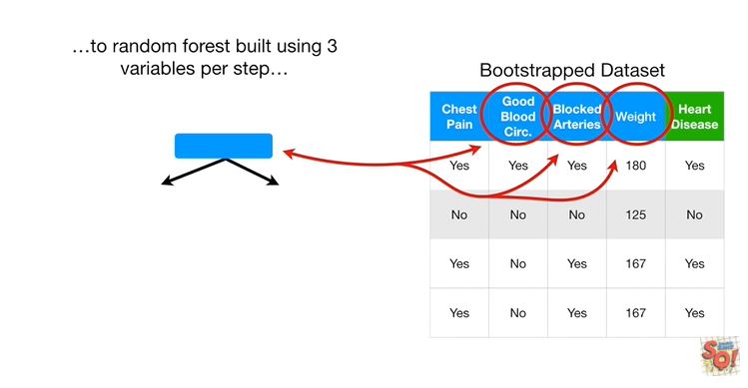

to a random forest built using three variables per step

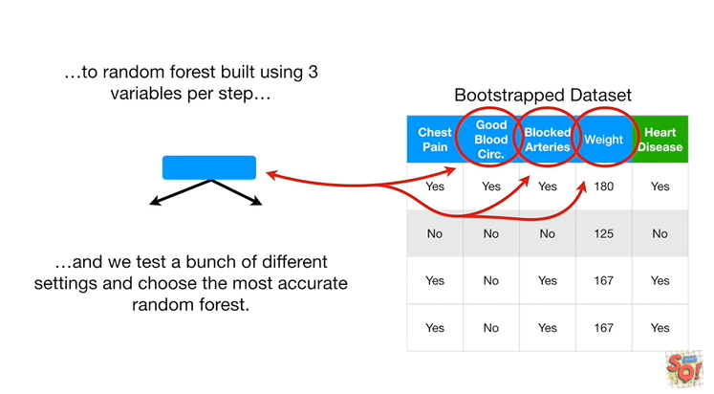

and we test a bunch of different settings and choose the most accurate random forest.

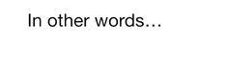

In other words :

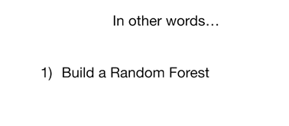

1. we build a random forest

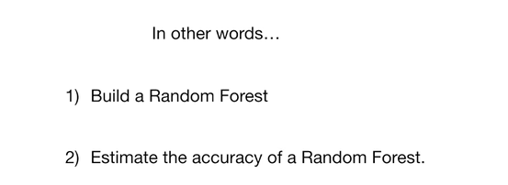

and then 2. we estimate the accuracy of a random forest.

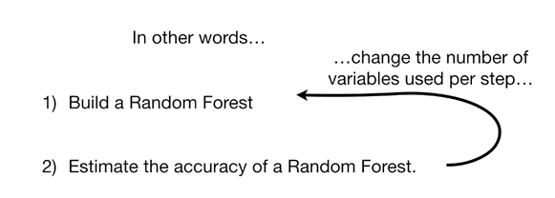

Then we change the number of variables used per step

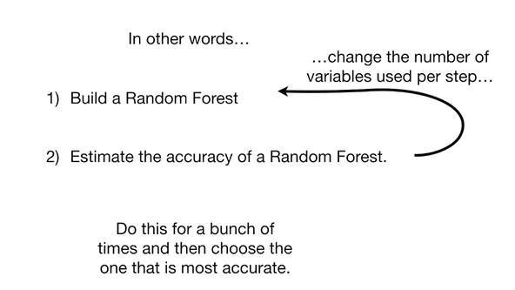

and we do this a bunch of times and then choose the one that is the most accurate.

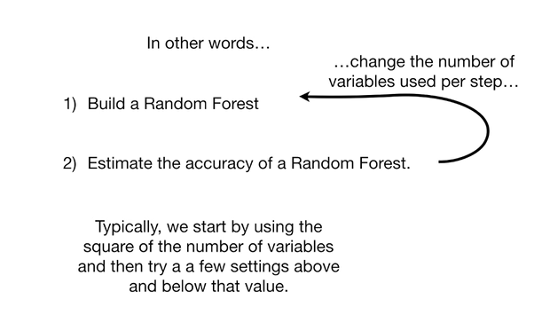

Typically, we start by using the square of the number of variables and then try a few settings above and below that value.

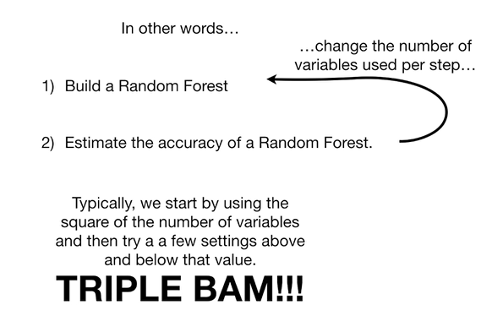

Triple BAM !!!